Lu Feng: Understanding the New Round of Global Sovereign Debt Risk from an Economic Perspective (Global Development Workshop 19th)

Editor's Note:
The current global sovereign debt crisis is inflicting significant damage on sustainable development and people's well-being in many developing nations and emerging economies, along with creating economic uncertainty worldwide. To address this pressing issue, this workshop has invited Professor Lu Feng from National School of Development, Peking University as the keynote speaker. Professor Lu will conceptually link internal and external imbalances based on the basic principles of open macroeconomics, analyze the underlying causes of excessive external debt within developing countries, and utilize empirical data from selected developing countries in the context of the above discussion to make policy recommendations for prudent external debt management.

Lu Feng: Understanding the New Round of Global Sovereign Debt Risk from an Economic Perspective
The focus of today's lecture is on the topic of sovereign debt risk and its impact on the economy, which has become a pressing issue for policymakers and stakeholders across various countries. While pursuing economic development, borrowing from external sources is often necessary for investment in domestic construction and economic growth. However, excessive borrowing can lead to unsustainable debt burden, which may pose default risks and crisis. Effectively managing sovereign debt and striking a balance between borrowing and development is a complex and challenging undertaking. During this lecture, we will discuss the current global research data and sovereign debt situation using empirical data, as well as introduce a theoretical perspective on this subject from a macroeconomic viewpoint. The lecture will also delve into understanding the state of rising global debt risk and international cooperation in coping with it.
As the world faces the repercussions of a new wave of sovereign debt crises, the international community has become aware of the importance and urgency of comprehensively addressing rising debt risks, including multilateral governance. During the recent spring meetings of the International Monetary Fund and the World Bank, member countries discussed this crisis as the primary topic. The meeting highlighted the significance of international cooperation in effectively managing, mitigating, and ultimately resolving debt crises in countries such as Sri Lanka and Ghana. It also focused on the multilateral development banks and the International Development Association's positive role in alleviating the distressed countries' debt crisis and accelerating debt treatment and restructuring processes through financial support, policy concessions, and ex ante debt relief. Certain aspects of these efforts are consistent with China's previous advocacy for global cooperation in debt reduction, indicating that the international community has made constructive progress in prudently addressing sovereign debt risks.

Sovereign Debt: Concept and History
To discuss sovereign debt risk, it is crucial to first clarify the concept of sovereign debt. The exact definition of sovereign debt involves various complex factors, but it generally refers to a country's borrowing from non-resident foreign market participants to finance its debts, mainly in foreign currency, based on sovereign credit ratings. A sovereign debt default occurs when a government fails to meet the terms of the debt contract and pay its debt. As sovereign debt is mainly denominated in foreign currencies, governments cannot address debt service shortfalls by merely issuing more local currency, and therefore, a country-specific debt service shortfall can result in a debt default crisis with a range of knock-on effects. Recent experience has shown that in individual developing countries like Sri Lanka, an insolvency crisis can also create the risk of national bankruptcy due to the fragility of their economy and domestic governance. Enabling countries in debt distress to manage their external debt effectively is critical to the development of global financial stability and requires special help from the international community.

Debt defaults have been a longstanding issue for many developing and emerging economies. As shown in Figure 1, sovereign debt defaults were relatively uncommon after World War II; however, there was a steady increase in their incidence from the 1970s onwards. Coordinated by the IMF and the World Bank, debt crises in Latin American nations such as Mexico, Brazil, and Argentina during the 1980s, and the debt problems of heavily indebted poor countries (HIPs) after the mid-1990s, were effectively addressed, and global debt defaults dropped to lower levels in the early 21st century. However, after the middle of the second decade of this century, the problem has reemerged. Rough estimates indicate that as many as 15 countries worldwide faced sovereign debt risk at the beginning of this year, and according to data reported during the IMF-WB Annual Spring Meeting in the media, the number of crisis countries has now risen to 21. While the impact of the COVID-19 pandemic on the global economy can be viewed as last straw for these countries, the underlying causes of the increased debt crisis pressure are likely to be much broader and far-reaching.

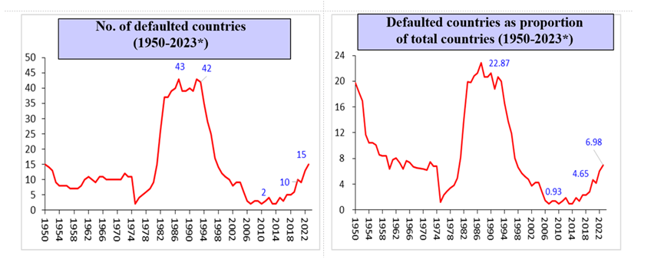
Fig.1
In the broader context of global development, the sovereign debt of developing countries has surged to unprecedented levels. As indicated in Figure 2, the total debt of middle-income and low-income developing countries has grown faster than their gross national income (GNI) or gross domestic product (GDP). Low growth rates, rising inflation, falling export growth, and declining foreign direct investment (FDI) inflows have led to a sharp decline in foreign exchange reserves, indicating that these countries are less resilient to financial risks and that macroeconomic growth is under pressure, which is the primary cause of the debt crisis. In terms of external factors, as exhibited in Figure 3, authorities at both the Federal Reserve and the European Central Bank have massively increased interest rates in response to inflation brought about by stimulus packages, even by approximately 4.75 basis points in the past year alone, unprecedented in modern history. Consequently, borrowing costs have skyrocketed, and the liquidity of capital has become restricted in international capital markets, thereby increasing the pressure on developing countries to pay off their debt. Additionally, borrowing from international capital markets implies higher sovereign debt risk for many developing countries than borrowing from official bilateral credit agencies or multilateral financial institutions. Furthermore, the emergence of creditor countries such as China has led to new perspectives and ideas regarding debt management among the international community. Thus, while partial measures have been applied to assist countries facing debt distress, the debt relief process has not been as speedy as anticipated, leading to a more divisive and convoluted process, making the debt problem more challenging.

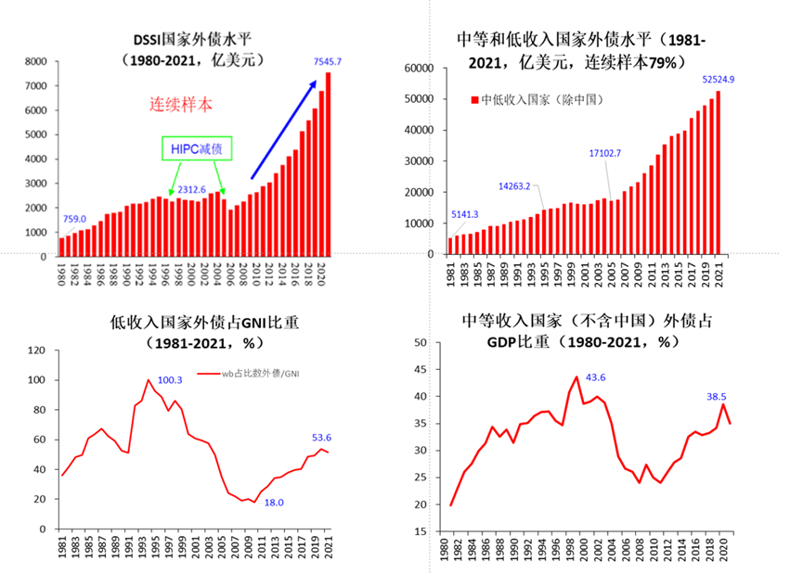

Fig.2

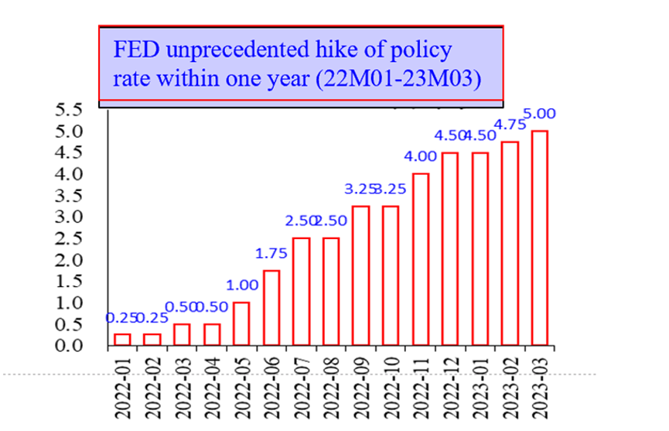
Fig.3

Understanding the new round of global sovereign debt risk from a macroeconomic perspective
To understand the causes of the sovereign debt crisis through a macroeconomic lens, we can examine the internal and external imbalances, which involve comprehending three equations.
The first equation is "CA_{t} = S_{t} - I_{t}," which means that the current account balance equals domestic savings minus inward investment. The current account balance is equivalent to total savings (GDP minus the total consumption, which can be separated into public and private consumption). In other words, the gross savings value is equal to GDP minus the sum of private and public consumption, while investment comprises public and private sector investment. Therefore, this equation signifies that the current account balance equals GDP minus the sum of private and public consumption, followed by the subtraction of private and public sector investment. This equation links the external imbalance, as measured by the current account balance, to the domestic savings gap. In developing countries, the domestic savings gap typically occurs simultaneously in two ways: a current account deficit arises when a country saves less than it invests, while a falling exchange rate occurs when a country exports less than it imports. On either side of the equation, internal and external development imbalances are defined by the savings-investment relationship and the current account balance, establishing a link.
The second equation, "CA_{t} = -KA_{t}," states that the capital account balance is equal to the negative of the current account balance. A country with a current account deficit must have a capital account surplus and vice versa. When a country has a current account deficit, it requires net foreign exchange inflows to achieve a balance of payments. Therefore, it needs to acquire capital from external sources through foreign direct investment, portfolio investment and other forms of borrowing in both broad and narrow senses. In terms of a country's net external investment position (NIIP), net foreign exchange inflows also indicate an increase in the country's broad debt.
This leads us to the third equation: "δNIIP = Net Equity Inflow + Net Debt Inflow," which means that the change in a country's net external investment position is equal to the sum of its net debt inflow and net equity inflow. Net Debt Inflow refers to inflows to a country through loans or bond purchases, while Net Equity Inflow refers to inflows to a country through equity investments. In international finance, the net international investment position (NIIP) represents the difference between a country's foreign investment and that other countries, measuring the flow of equity and liability funds between nations. NIIP is positive if a country invests more in foreign countries than the foreign investment in that country. Conversely, if foreign investment in the country is greater, the NIIP value is negative. By definition, NIIP is impacted by changes in the capital and current accounts, closely tied to a country's balance of payments. This equation suggests that a country's total stock of foreign debt at a specific time is the summation of net debt inflows accumulated over previous historic periods, originating from either the current account deficit or the savings and investment gap. The interplay of these factors determines the level of a country's debt accumulation, influencing its investment and development plans.
The preceding discussion highlights two principles. Firstly, significant and persistent current account deficits can indicate a country's potential sovereign debt crisis, necessitating our vigilance. Secondly, it is crucial to maintain robust, stable, and balanced GDP growth in the domestic economy to curb the current account deficit and prevent excessive borrowing. Moreover, balanced economic growth helps avert adverse consequences stemming from excessive consumption or investment in both the private and public sectors, ensuring sustainable development. Additionally, balanced economic growth serves to mitigate the negative impacts of excessive private and public sector consumption or investment and promotes sustainable national development.

Sovereign debt crises: a case study
As shown in Figure 4, Sri Lanka's GDP growth has significantly contracted, with the country's total GDP value declining by a cumulative 15.6% from the fourth quarter of 2018 to the present. Moreover, inflation is rampant, and a significant gap exists between supply and demand, giving rise to severe macroeconomic imbalances and deficits, which have necessitated ever-increasing levels of debt. The Sri Lankan government debt-to-GDP ratio has even surpassed 100%. The country's inability to generate sufficient revenue to meet its domestic expenditures has led to a current account deficit, further exacerbating to external debt The expanding savings gap in Sri Lanka over the past decade has fueled the current account deficit, with external debt increasing to over 70% of GDP in 2021. The country's debt position has been further compromised by the Federal Reserve's interest rate hikes due to extensive borrowing from bonds issued on international capital markets.
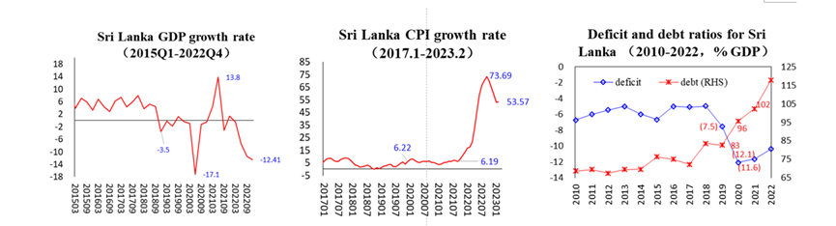
Fig.4
The deteriorating balance of payments in Sri Lanka has eroded national confidence in the national currency, resulting in a weakening exchange rate, capital flight, and a steady decrease in the country's foreign exchange reserves. In 2019 alone, reserves declined from US$6.6 billion (equivalent to 7.4% of GDP) to US1.9 billion (representing only 1.2% of GDP). These are concerning figures. To secure foreign currency for essential food and fuel imports, Sri Lanka had to halt repayments of foreign debt from April 12th, 2022, leading to the nation being declared a sovereign debt defaulter with the announcement of national bankruptcy in July. In response, the International Monetary Fund (IMF) extended a four-year, US$3 billion rescue package to aid in stabilizing Sri Lanka's domestic and external economic development. Recently, relevant agencies in the country issued a financial assurance to permit the IMF to initiate its rescue process, paving the way for further assistance to Sri Lanka.
Similar to Sri Lanka, Pakistan has also been confronted with sovereign debt distress in recent years. While the nation has not formally defaulted on its debt, repeated payment delays on bilateral contracts with China, Saudi Arabia, and other countries suggest it is at a greater risk of default. Macroeconomic data shows similar rationales and factors underlying the debt difficulties of countries. Though Pakistan's GDP growth has been more positive, the high inflation rate indicates an imbalance between aggregate demand and supply within the domestic market. Furthermore, the government deficit has grown alarmingly, with debt as a percentage of GDP climbing to as high as 70%-80%. Pakistan's current account balance is contracting, and the Pakistani rupee exchange rate has dropped significantly, draining domestic foreign exchange reserves to a precarious 1.6% of GDP, an alarming situation for a country as substantial as Pakistan.

A Conclusion
Based on the theoretical discussion and case studies presented above, we can offer several practical policy recommendations for addressing the new round of global debt risks. Firstly, economic policy should prioritize sustainable growth over speed, regularly adjusting to the country's developmental realities to achieve stable and balanced growth. Secondly, excessive material deficits must be avoided to ensure economic development and the well-being of citizens without overextending resources or risking high inflation rates, enhancing the country's resilience to external shocks. Finally, the current account deficit should be prudently managed to ensure balanced internal and external economic development while avoiding the accumulation of excessive foreign sovereign debt via diligent monitoring.
The global community is currently experiencing a new wave of sovereign debt crises, which presents both opportunities and challenges for developing countries such as China. We must learn from these experiences and lessons when managing sovereign debt risks, while also strengthening our cooperative efforts with other nations to address this issue more effectively.

Guest Commentary:
The issue of sovereign debt in international economic relations is complex, with diverse responses and varying definitions and approaches across different countries. To comprehend sovereign debt crises, one must understand the distinctions between private and sovereign debt, as well as the different perceptions of responsibility among financial actors such as private creditors, governments, and the bond market. In countries with electoral systems, achieving consensus among these groups be difficult. Furthermore, comprehending the history of debt problems is critical in establishing criteria for debt restructuring and resolution. Finally, awareness of debt traps is crucial for both borrowers and lenders, as paying interest on external debt can lead to a cycle of unsustainable accumulation. The causes of excessive debt can be endogenous or exogenous, negatively impacting both borrowers and lenders. In conclusion, understanding the complexity of the debt problem is essential for achieving a fair and sustainable resolution to debt crises without jeopardizing the well-being of either borrowers or lenders.
Regarding how to resolve the current debt crisis, there is a general consensus among creditors that funding should be spread out, and the IMF and World Bank no longer offer debt relief opportunities. As a result, the current debt service initiative merely extends payment terms without reducing the amount of principal or interest. However, the question of who should provide the debt reduction funds has become a new challenge. In recent years, the term "senior creditors" has emerged, referring to creditors who lend to low- and middle-income countries. In the past, it specifically applied to members of the Paris Club or, more generally, to members of the OECD. Additionally, the London Club is involved in lending to these countries as a committee of private banks and financiers. These commercial banks are mostly active in the bond market, primarily in currencies like the US dollar and the euro.
There is also a group of creditors who believe that developing rules and consensus among stakeholders is crucial for resolving the crisis. Although the G20 summit arrived at a debt reduction program, only three borrower countries ultimately joined the initiative. The questions remain: who should provide the funding? Will it be junior creditors, or is there a Beijing Club comprised of China, India, Brazil, and countries such as the UAE and Saudi Arabia? Negotiations continue, but the primary concern is assisting the struggling countries to emerge from this crisis with minimal cost.

Q&A:
Q: Is the flexibility of currency exchange rates positively or negatively influencing on the country's response to the debt crisis?
A: Exchange rate regimes and their level of flexibility can have a significant impact on a country's external balances. It is widely recognized that a stable exchange rate provides a consistent environment for economic growth and helps businesses and market players make more accurate predictions about the future. Developing countries, in particular, benefit from this stability. However, a fixed exchange rate can become a liability if a country's competitiveness declines, as it would impede the generation of enough exports to maintain sustainable foreign trade. In these cases, exchange rates must be adjusted to meet current needs, making flexibility a necessary factor.

Translated by: Feng Liwen

